



WebMinds, Inc.

TM

Version v6.0

Version

Copyright © WebMinds, Inc., 2024

All Rights Reserved

This publication is protected by federal copyright law. No part of this publication may be copied or distributed, stored in a retrieval system, or translated into any human or computer language in any form or by any means, electronic, mechanical, magnetic, manual or otherwise, or disclosed to third parties without the express written permission of **WebMinds, Inc.**

**WebMinds, Inc.** makes no representation or warranties with respect to the contents hereof and specifically disclaim any implied warranties of merchantability or fitness for a particular purpose. Further, **WebMinds, Inc.** reserves the right to revise this publication and to make changes from time to time in the contents hereof without obligation of **WebMinds, Inc.** to notify any person or organization of such revision or changes.

**WebMinds, Inc.** has prepared this guide for use by **WebMinds, Inc.** personnel and authorized third parties as a guide to proper operation and/or maintenance of **WebMinds, Inc.** equipment and software. The drawings and specifications contained herein are the property of **WebMinds, Inc.**

Trademarked names may appear throughout this user manual. Rather than list the names and entities that own the trademarks or insert a trademark symbol with each mention of the trademarked name, the names are used only for editorial purposes and to the benefit of the trademark owner with no intention of infringing upon that trademark.

Address comments and corrections to:

**WebMinds, Inc.**

950 N Collier Blvd. Suite 400

Marco Island FL 34145

USA

Revision History

|  |  |  |  |
| --- | --- | --- | --- |
| Date | Release | Revision DESCRIPTION | MODIFIED BY |
| Dec 18, 2023 | 0.1 | Initial draft | David A. Flynn |
| Dec 29, 2023 | 1.0 | First base lined user manual | David A. Flynn |
|  |  |  |  |
|  |  |  |  |
|  |  |  |  |
|  |  |  |  |

About this User Manual

This user manual contains information about the all features & functionalities of the NetOptimizerTM application and instructions on how to use them.

Purpose of this User Manual

The purpose of this user manual is to assist the end users of the TM application.

In Scope of this User Manual

The scope of this user manual includes the description and usage of the TM application.

Out of Scope of this User Manual

The scope of this user manual does not include –

* the detailed installation process of TM application
* the usage of the features and functionalities of your operating system

Intended Audience of this User Manual

The intended audiences of this user manual are –

* end users of the TM application

Organization of this User Manual

This user manual contains 10 chapters & 1 appendices as indicated below –

|  |  |
| --- | --- |
| chapter | Description |
| **Chapter 1** | Introduction |
| **Chapter 2** | Getting Started |
| **Chapter 3** | Using the Auto Mode |
| **Chapter 4** | Using the Advanced Mode |
| **Chapter 5** | Viewing the Wi-Fi Passwords |
| **Chapter 6** | Using the Browser Cleanup Feature |
| **Chapter 7** | Using the Speed Test Feature |
| **Chapter 8** | Using the Diagnostic Troubleshooting Feature |
| **Chapter 9** | Activating your NetOptimizer TM Installation |
| **Chapter 10** | Removing your NetOptimizer TM License Key |
| **Appendix A** | Frequently Asked Questions |

Typographical Conventions / Customaries used in this User Manual

The typographical conventions used in this user manual include the following –

* **Note:** The purpose of this typographical convention is to provide important information corresponding to an already stated fact. This is how we depict a note in this user manual –

**Note:**<Note Text><Note Text><Note Text><Note Text><Note Text><Note Text><Note Text><Note Text><Note Text><Note Text><Note Text><Note Text><Note Text><Note Text>

* **Tip:** The purpose of this typographical convention is to provide additional information supplementing an already stated fact. This is how we depict a tip in this user manual –

**Tip:**<Tip Text><Tip Text><Tip Text><Tip Text><Tip Text><Tip Text><Tip Text><Tip Text><Tip Text><Tip Text><Tip Text><Tip Text><Tip Text><Tip Text><Tip Text><Tip Text><Tip Text>

* **Warning:** The purpose of this typographical convention is to provide critical information corresponding to an already stated fact. This is how we depict a warning in this user manual –

**Warning:**<Warning Text><Warning Text><Warning Text><Warning Text><Warning Text><Warning Text><Warning Text><Warning Text><Warning Text><Warning Text><Warning Text>

* **Reference:** The purpose of this typographical convention is to refer you to another section in this user manual or another document or to an external reference. A reference is depicted in the following manner in this user manual –

**Reference:** To read detailed steps, navigate to **<Chapter Name>** chapter by clicking this link.

or

**Reference:** For more information, navigate to **<Chapter Name>** chapter by clicking this link.

Abbreviations / Acronyms used in this User Manual

The table below describes the abbreviations / acronyms used in this user manual –

|  |  |
| --- | --- |
| Abbreviation | Description |
| **GUI, UI** | Graphical User Interface, User Interface |
| **IPR** | Intellectual Property Rights |
| **NO** | NetOptimizer |
| **TM** | Trade Mark |
| **TOC, TOT, TOF** | Table of Contents, Table of Tables, Table of Figures |
| **PC** | Personal Computer |
| **FAQs** | Frequently Asked Questions |

Terms Used in this User Manual

The below table briefly describes the terms utilized in this user manual –

| chapter | Description |
| --- | --- |
| **End User** | An operator or user of the NetOptimizer TM application. |

Table of Contents

Revision History ii

About this User Manual iii

Purpose of this User Manual iii

In Scope of this User Manual iii

Out of Scope of this User Manual iii

Intended Audience of this User Manual iii

Organization of this User Manual iii

Typographical Conventions / Customaries used in this User Manual iv

Abbreviations / Acronyms used in this User Manual v

Terms Used in this User Manual v

Table of Contents 6

Table of Figures 8

Chapter - 1. Introduction 10

Chapter - 2. Getting Started 11

Chapter - 3. Using the Auto Mode 13

Chapter - 4. Using the Advanced Mode 16

4.1 Optimizing Data Caching Settings 17

4.2 Optimizing DNS Server Settings 19

4.3 Optimizing Host Resolution Priority Settings 22

4.4 Optimizing I/O Latency Settings 24

4.5 Optimizing Internet Connection Speed Settings 26

4.6 Optimizing Metered Connection Settings 28

4.7 Optimizing Network Efficiency Settings 30

4.8 Optimizing Network Performance Settings 32

4.9 Optimizing Network Throughput Settings 34

4.10 Optimizing Packet Coalescing Settings 36

4.11 Optimizing QoS Reserved Bandwidth Settings 38

Chapter - 5. Viewing the Wi-Fi Passwords 40

Chapter - 6. Using the Browser Cleanup Feature 41

Chapter - 7. Using the Speed Test Feature 44

Chapter - 8. Using the Diagnostic Troubleshooting Feature 46

Chapter - 9. Activating your NetOptimizerTM Installation 47

Chapter - 10. Removing your NetOptimizerTM License Key 49

Appendix - A. Frequently Asked Questions (FAQs) 51

Index 55

Table of Figures

Figure 1 – Downloading the NetOptimizerTM application installer executable file 10

Figure 2 – NetOptimizerTM default screen 11

Figure 3 – Running the Auto Mode wizard 13

Figure 4 – Automatic execution of the Auto Mode system analysis wizard 13

Figure 5 – Apply optimized network settings? 14

Figure 6 – Key application popup 14

Figure 7 – Successful application of your license key 15

Figure 8 – Restarting your system 15

Figure 9 – Using the Advanced Mode 16

Figure 10 – Advanced Mode screen 16

Figure 11 – Advanced Mode screen 17

Figure 12 – Data caching easel 17

Figure 13 – Advanced Mode screen 19

Figure 14 – DNS servers easel 20

Figure 15 – DNS server selection popup 20

Figure 16 – Advanced Mode screen 22

Figure 17 – Data caching easel 23

Figure 18 – Advanced Mode screen 24

Figure 19 –I/O latency easel 25

Figure 20 – Advanced Mode screen 26

Figure 21 – Internet connection speed easel 27

Figure 22 – Advanced Mode screen 28

Figure 23 – Metered connection easel 29

Figure 24 – Advanced Mode screen 30

Figure 25 – Network efficiency easel 30

Figure 26 – Advanced Mode screen 32

Figure 27 – Network performance easel 32

Figure 28 – Advanced Mode screen 34

Figure 29 – Network throughput easel 34

Figure 30 – Advanced Mode screen 36

Figure 31 – Packet coalescing easel 36

Figure 32 – Advanced Mode screen 38

Figure 33 – QoS reserved bandwidth easel 39

Figure 34 – Viewing the Wi-Fi Passwords 40

Figure 35 – Automatic execution of the Auto Mode system analysis wizard 40

Figure 36 – Using the Browser Cleanup Feature 41

Figure 37 – Browser cleanup screen 41

Figure 38 – Querying for Cleanup task confirmation 42

Figure 39 – Querying for closing open web-browsers 42

Figure 40 – Successful Operation completion status message 43

Figure 41 – Browser cleanup screen 43

Figure 42 – Using the Speed Test Feature 44

Figure 43 – Speed Test screen 44

Figure 44 – Collecting your Internet Connection Speed Statistics 45

Figure 45 – Your Internet Connection Speed Statistics 45

Figure 46 – Using the Diagnostic Troubleshooting Feature 46

Figure 47 – Diagnostic troubleshooting wizard 46

Figure 48 – Activating your NetOptimizerTM Installation 47

Figure 49 – Key application popup 47

Figure 50 – Successful application of your license key 48

Figure 51 – Viewing your license key details 48

Figure 52 – Removing your NetOptimizerTM License Key 49

Figure 53 – Viewing your license key details 49

Figure 54 – License key deactivation confirmation message 50

Figure 55 – License key deactivation successfully status message 50

# Introduction

In today’s digital age, a slow wifi connection can be a major source of frustration. Whether you’re trying to stream your favorite show, work from home, or simply browse the internet, a sluggish connection can bring everything to a halt.

**Reference:** To read about common issues which may contribute to slowing your wifi connection, visit [**https://www.netoptimizer.com/how-to-fix-slow-wifi/**](https://www.netoptimizer.com/how-to-fix-slow-wifi/)

Once you are sure that all of the issues mentioned in the article above have been taken care off, you can download the NetOptimizer TM application from the **Download** link available in the menu on the NetOptimizer TM homepage or by clicking the **Free Download** button as depicted in the figure below –

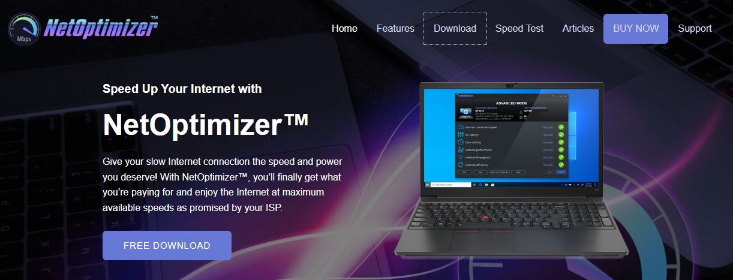

Figure – Downloading the NetOptimizerTM application installer executable file

**Tip:** After you click the above-mentioned links, you may be warned by your web-browser about a potential security risk due to the downloaded executable file. Please authorize this file.

You can follow the installation wizard by launching the downloaded NetOptimizer TM installer executable file to install the NetOptimizer TM application on your system.

**Tip:** After you open the downloaded executable file, you may be warned by your operating system before you install this application on your system. Please authorize your operating system to continue installing this application at this step.

The next chapter describes steps that enable you to get started with the NetOptimizer TM application.

# Getting Started

After you launch the NetOptimizer application, your internet summary details are fetched and the default screen is displayed as depicted in the figure below –

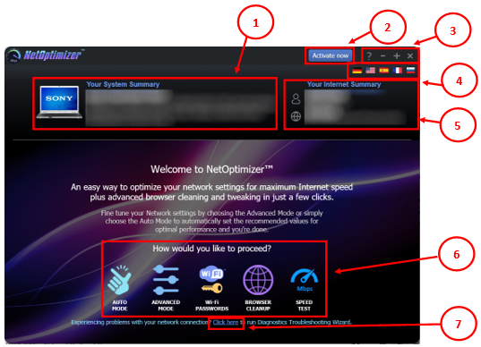

Figure – NetOptimizerTM default screen

Below is a description of the screen elements of the default screen of the TM application.

| **NO.** | **DESCRIPTION** |
| --- | --- |
| **1** | This section of the screen displays your system summary details. |
| **2** | Clicking the **Activate Now** button enables you to activate your subscription plan by specifying your email address and the key provided to you after you purchase a subscription plan suitable to you.  **Reference:** To read the detailed steps, navigate to **Activating your NetOptimizerTM Installation** chapter by clicking this link. |
| **3** | Below are the descriptions of the buttons available in this section of the screen –   * **Question Mark (?)** – Clicking this button opens the **About** popup which displays the details of your NetOptimizer installation. E.g. license details, etc. * **Minus (-)** – Clicking this button enables you to minimize this screen * **Plus (+)** – Clicking this button enables you to maximize this screen * **Cross (x)** – Clicking this button enables you to close this screen |
| **4** | Clicking any of the national flags enables you to change the display language of your NetOptimizer installation. |
| **5** | This section of the screen displays your internet summary details. |
| **6** | Below are the descriptions of the buttons available in this section of the screen –   * **Auto Mode** – Clicking this button enables you to run the NetOptimizer TM wizard in automatic mode.   **Reference:** To read detailed steps, navigate to **Using the Auto Mode** chapter by clicking this link.   * **Advanced Mode** – Clicking this button enables you to run the NetOptimizer TM wizard in advanced mode   **Reference:** To read detailed steps, navigate to **Using the Advanced Mode** chapter by clicking this link.   * **Wi-Fi Passwords** – Clicking this button enables you to view the password of the wifi connection that your system is connected to.   **Reference:** To read detailed steps, navigate to **Viewing the Wi-Fi Passwords** chapter by clicking this link.   * **Browser Cleanup** – Clicking this button enables you to clean up the cache memory of the web browser of your choice   **Reference:** To read detailed steps, navigate to **Using the Browser Cleanup Feature** chapter by clicking this link.   * **Speed Test** – Clicking this button enables you to check your internet connection speed   **Reference:** To read detailed steps, navigate to **Using the Browser Cleanup Feature** chapter by clicking this link. |
| **7** | **Diagnostic Troubleshooting** – Clicking this link enables you to launch the Network Diagnostic Troubleshooting wizard of your operating system.  **Reference:** To read the detailed steps, navigate to **Using the Diagnostic Troubleshooting Feature** chapter by clicking this link. |

The next chapter describes steps that enable you to use the **Auto Mode** of the NetOptimizer TM application.

# Using the Auto Mode

The steps described below enable you to use the automatic mode of the NetOptimizerTM application –

1. From the default screen of the NetOptimizerTM application, click the **Auto Mode** button as depicted in the figure below.

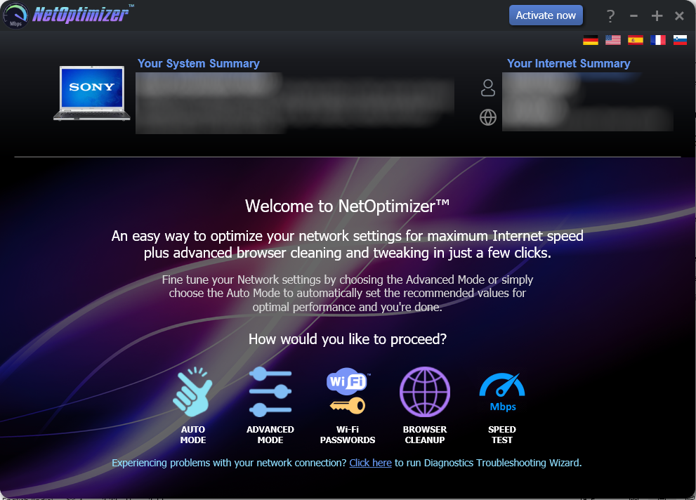

Figure – Running the Auto Mode wizard

The Auto Mode screen is displayed as depicted in the figure below –

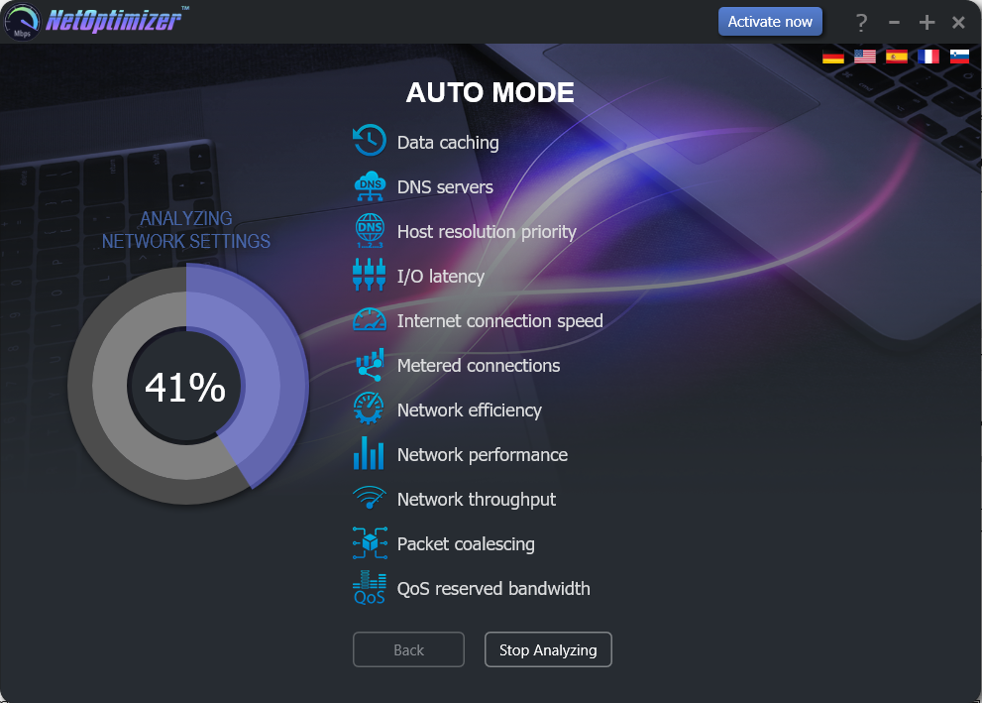

Figure – Automatic execution of the Auto Mode system analysis wizard

The wizard starts analyzing your system as soon as this screen is loaded.

**Tip:** To stop Analyzing your system click **Stop Analyzing** as depicted in the figure above. You can also navigate to the default screen by clicking the **Back** button after the analysis has stopped or completed.

1. After the wizard has analyzed your system, the optimized network settings choice popup is displayed as depicted in the figure below –

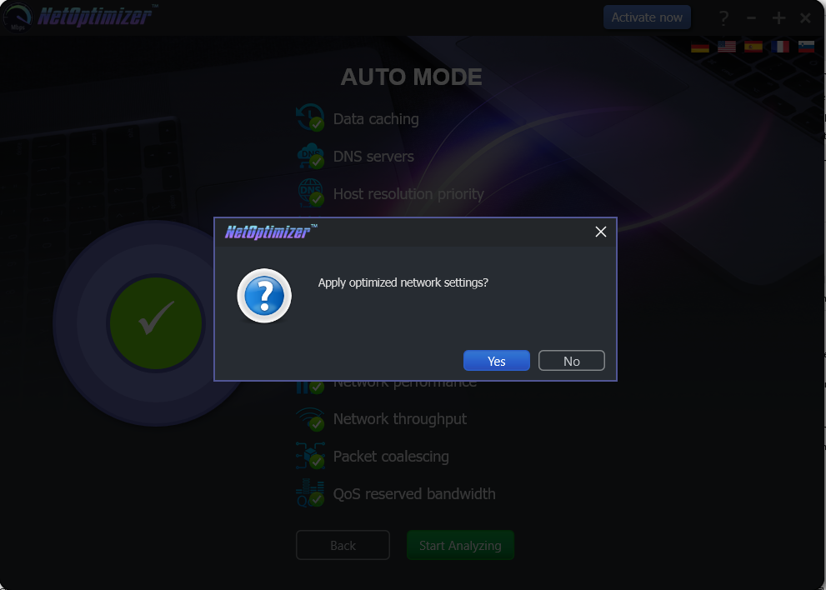

Figure – Apply optimized network settings?

Click **No** in case you would like to manually change required options before you apply each optimized setting.

**Reference:** For more information, refer to **Using the Advanced Mode** chapter by clicking this link.

Click **Yes** to continue applying the optimized network settings.

1. In case you have not purchased and applied a license key in your NetOptimizerTM application installation, a key application popup is displayed as depicted in the figure below –



Figure – Key application popup

1. Click the **Buy Now** button to avail the money saving offer depicted here.

**Tip:** You will be navigated to the NetOptimizerTM shopping cart web page in your default web browser. You can specify the required details, and click **Buy Now** on this web page to make your purchase. You will receive an email containing your license key details at the email address specified by you on this web page.

1. Once you have received your license key, specify your email address and license key and click the **Submit** button. After successful validation of the specified key, your NetOptimizerTM installation will be activated and a popup will be displayed confirming the same as depicted in the figure below -

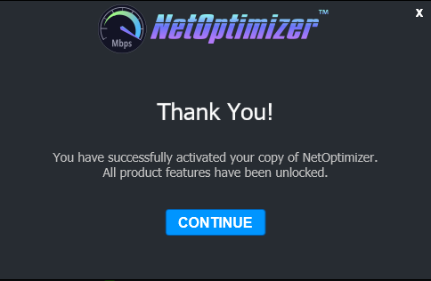

Figure – Successful application of your license key

1. Click **Continue** to continue using the NetOptimizerTM application. The application will create a restore point in your operating system and your optimized network settings will be applied. The application will also query you whether you would like to restart the system as depicted in the figure below.

**Tip:** The system needs to be restarted to apply the optimized network settings completely and to be loaded by your operating system.

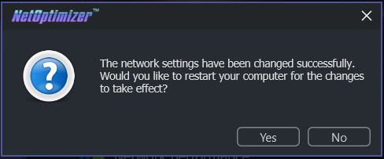

Figure – Restarting your system

1. Click **Yes** to restart your system.

The next chapter describes steps that enable you to use the **Advanced Mode** of the NetOptimizer TM application.

# Using the Advanced Mode

The steps described below enable you to use the advanced mode of the NetOptimizerTM application –

1. From the default screen of the NetOptimizerTM application, click the **Advanced Mode** button as depicted in the figure below.



Figure – Using the Advanced Mode

The Advanced Mode screen is displayed as depicted in the figure below –

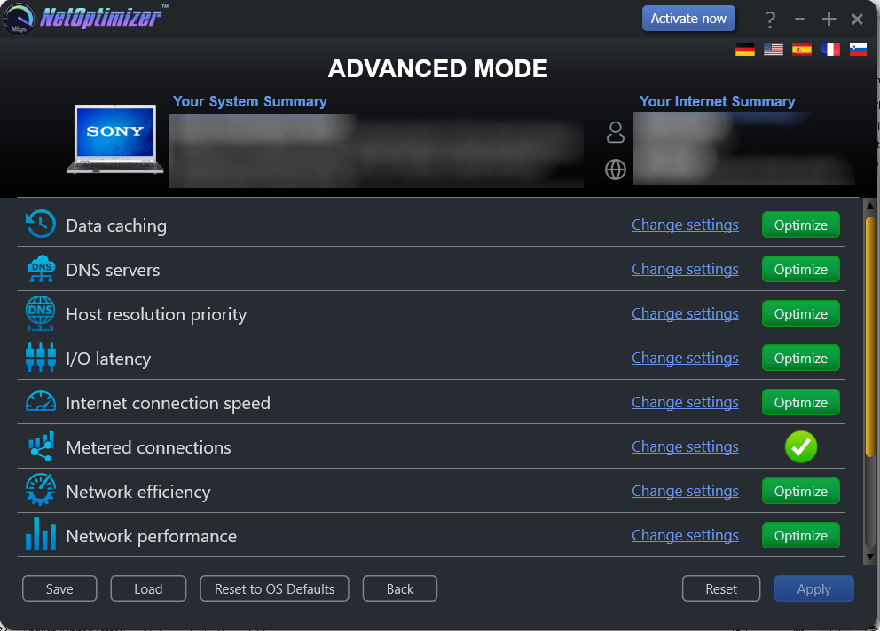

Figure – Advanced Mode screen

Perform the steps described in each of the following sub-sections to perform one or more of the network optimization tasks as per your requirements.

## Optimizing Data Caching Settings

To optimize data caching, the NetOptimizerTM application optimizes the **Time to Live** setting.

The **Time to Live (TTL)** setting tells each of the routers between your system and the intended target server as to how long a data packet should persist in your network while it attempts delivery before abandoning delivery and discarding the aforementioned data packet.

When the value is set high, your computer spends more time waiting for a failed packet to deliver, effectively decreasing the productivity in your network.

The steps described below enable you to optimize data cache settings of your system –

1. From the Advanced Mode screen of the NetOptimizerTM application, click the **Change Settings** link as depicted in the figure below –



Figure – Advanced Mode screen

The Data caching easel is opened as depicted in the figure below –

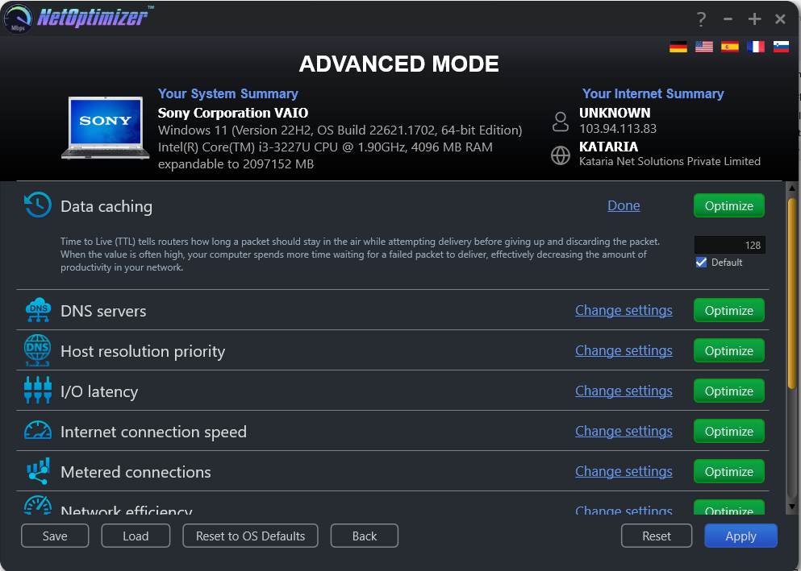

Figure – Data caching easel

1. Change the **Time to Live (TTL)** parameter as per your requirements and click the **Optimize** button. The green **Optimize** button is replaced by a blue **Pending** button.

**Tip:** Click the **Default** checkbox to revert to the default parameter settings. You can also click the **Done** link to close this easel.

**Tip:** In case you want to revert to the previous settings, click **Revert.**

**Tip:** To save your current settings, click **Save.** The Saves As dialog box is displayed which enables you to specify a folder location on your hard disk drive to save your current settings as a NetOptimizer presets (**\*.nop**) settings file. You can also save these settings on a USB thumb drive in case you want to load these settings on another system.

**Tip:** To load previously saved settings, click **Load.** The Open dialog box is displayed which enables you to navigate to the previously saved NetOptimizer presets (**\*.nop**) settings file.

**Tip:** To revert to the default settings of your operating system, click **Reset to OS Defaults.** NetOptimizerTM will reset all settings to default values of your Operating System.

**Tip:** To return to the NetOptimizerTM default screen, click **Back.**

1. Click **Apply** to apply your updated settings.

**Tip:** The system will prompt you to Restart your system. Click **Yes** to continue restarting your system or you can choose to click **No** to make changes to other settings.

**Tip:** After you have restarted your system, a green checkbox will be displayed against the optimized and saved setting.

## Optimizing DNS Server Settings

To optimize DNS server settings, the NetOptimizerTM application optimizes the **Primary DNS & Secondary DNS** server IP Address settings.

A **Domain Name System (DNS)** server is used by your network to locate an IP address corresponding to your domain name. When you open a website by specifying a URL or website link in the address bar of your browser, the DNS Servers resolve the IP Address of the server of this website by matching it with the specified URL or webpage link.

Typically, while restarting or booting up your system, it acquires an IP address from your nearest router using the **Dynamic Host Control Protocol (DHCP)** settings automatically. Sometimes, while using the DHCP setting, the IP Address of your system and / or the IP Address of the web server take longer than expected to get resolved. This happens primarily because your system first attempts to fetch your network’s Primary and DNS server IP Addresses. This effectively decreases the productivity in your network.

Thus, by manually specifying the Primary & Secondary DNS Server IP Addresses, your system does not require querying your network for the involved DNS Servers. Your system simply attempts IP Address resolution from the explicitly specified IP Addresses of the Primary & Secondary DNS servers.

The steps described below enable you to optimize DNS server settings of your system –

1. From the Advanced Mode screen of the NetOptimizerTM application, click the **Change Settings** link as depicted in the figure below –



Figure – Advanced Mode screen

The DNS servers easel is opened as depicted in the figure below –

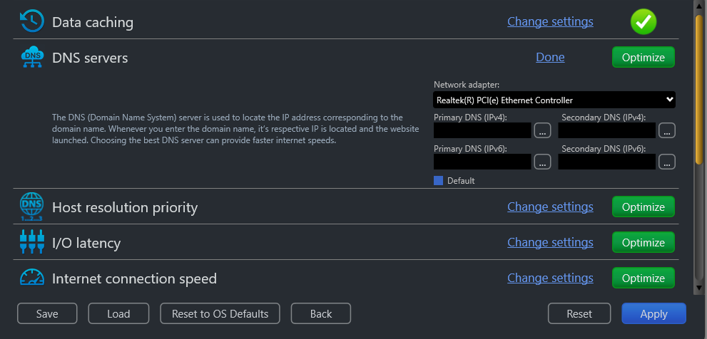

Figure – DNS servers easel

1. Select your Network Adapter from the corresponding drop-down box and then specify the **Primary DNS** & **Secondary DNS** IP Addresses by typing manually in the corresponding fields as per your requirements. Or you can click the corresponding **Ellipsis (…)** button next to the Primary DNS field. The DNS server selection popup is displayed as depicted in the figure below –

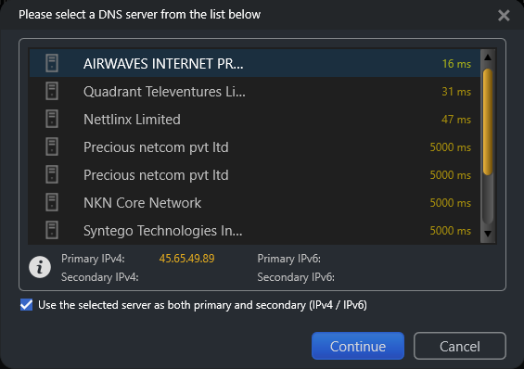

Figure – DNS server selection popup

1. Select the DNS Server of your choice and click **Continue**. The specified IP address is populated in the corresponding DNS server field in the DNS servers easel. Alternatively, you can click **Cancel** to return to the previous screen. Repeat this step for Secondary DNS also.
2. After you are done specifying the Primary and Secondary DNS Server IP Addresses, click the **Optimize** button. The green **Optimize** button is replaced by a blue **Pending** button.

**Tip:** Click the **Default** checkbox to revert to the default parameter settings. You can also click the **Done** link to close this easel.

**Tip:** In case you want to revert to the previous settings, click **Revert.**

**Tip:** To save your current settings, click **Save.** The Saves As dialog box is displayed which enables you to specify a folder location on your hard disk drive to save your current settings as a NetOptimizer presets (**\*.nop**) settings file.

**Tip:** To load previously saved settings, click **Load.** The Open dialog box is displayed which enables you to navigate to the previously saved NetOptimizer presets (**\*.nop**) settings file.

**Tip:** To revert to the default settings of your operating system, click **Reset to OS Defaults.** NetOptimizerTM will reset all settings to default values of your Operating System.

**Tip:** To return to the NetOptimizerTM default screen, click **Back.**

1. Click **Apply** to apply your updated settings.

**Tip:** The system will prompt you to Restart your system. Click **Yes** to continue restarting your system or you can choose to click **No** to make changes to other settings.

**Tip:** After you have restarted your system, a green checkbox will be displayed against the optimized and saved setting.

## Optimizing Host Resolution Priority Settings

To optimize host resolution priority settings, the NetOptimizerTM application optimizes the **Host Resolution Priority** to **Low** or **High** setting as required.

A **High** setting decreases the DNS / Hostname resolution priority of the below 4 related processes from their default setting. This decreases their priority compared to the hundreds of other running processes, while keeping their order.

* **LocalPriority = 499** default priority – local names cache
* **HostPriority = 500** default priority – the HOSTS file
* **DnsPriority = 2000** default priority – DNS host resolution
* **NetbtPriority = 2001** default priority – NetBT name resolution, including WINS

**Tip:** Lower numbers mean higher priority compared to other services. The above default values are high; thus, they decrease productivity.

When the value is set to **Low**, your computer takes lesser time to perform DNS / Hostname resolution, effectively increasing the productivity in your network.

The steps described below enable you to optimize host resolution priority settings of your system –

1. From the Advanced Mode screen of the NetOptimizerTM application, click the **Change Settings** link as depicted in the figure below –



Figure – Advanced Mode screen

The Host resolution priority easel is opened as depicted in the figure below –

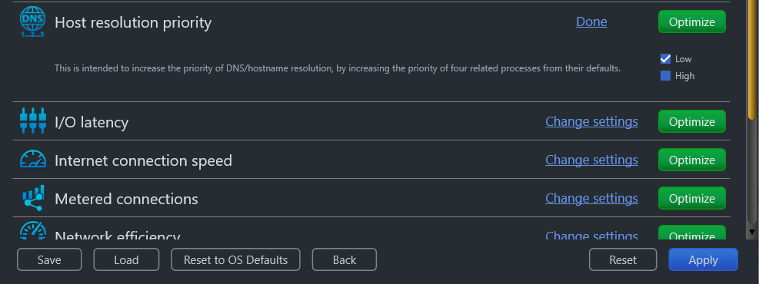

Figure – Data caching easel

1. Select the **Low** checkbox and click the **Optimize** button. The green **Optimize** button is replaced by a blue **Pending** button.

**Tip:** Click the **Default** checkbox to revert to the default parameter settings. You can also click the **Done** link to close this easel.

**Tip:** In case you want to revert to the previous settings, click **Revert.**

**Tip:** To save your current settings, click **Save.** The Saves As dialog box is displayed which enables you to specify a folder location on your hard disk drive to save your current settings as a NetOptimizer presets (**\*.nop**) settings file. You can also save these settings on a USB thumb drive in case you want to load these settings on another system.

**Tip:** To load previously saved settings, click **Load.** The Open dialog box is displayed which enables you to navigate to the previously saved NetOptimizer presets (**\*.nop**) settings file.

**Tip:** To revert to the default settings of your operating system, click **Reset to OS Defaults.** NetOptimizerTM will reset all settings to default values of your Operating System.

**Tip:** To return to the NetOptimizerTM default screen, click **Back.**

1. Click **Apply** to apply your updated settings.

**Tip:** The system will prompt you to Restart your system. Click **Yes** to continue restarting your system or you can choose to click **No** to make changes to other settings.

**Tip:** After you have restarted your system, a green checkbox will be displayed against the optimized and saved setting.

## Optimizing I/O Latency Settings

To optimize I/O latency settings, the NetOptimizerTM application optimizes the **Raw Receive Buffer** setting.

The I/O Latency is the time that your system takes by default in all input / output data packet transmission instances. The Disk I/O throughput during Read/Write instances is governed by the size of the **Raw Receive Buffers** within a server environment. This must be kept optimized to ensure better Disk I/O read / write times. This means it will affect your ability to host something in a high-latency environment. Let's say, for example, you host a game server and tons of people complain about lag. Modifying this value will help reduce the impact of lag. You'd also benefit if you're hosting a website or any other service.

When the value is set higher than the default value, your computer spends lesser time with each Disk I/O action, effectively increasing the productivity in your network.

The steps described below enable you to optimize I/O latency settings of your system –

1. From the Advanced Mode screen of the NetOptimizerTM application, click the **Change Settings** link as depicted in the figure below –



Figure – Advanced Mode screen

The I/O latency easel is opened as depicted in the figure below –

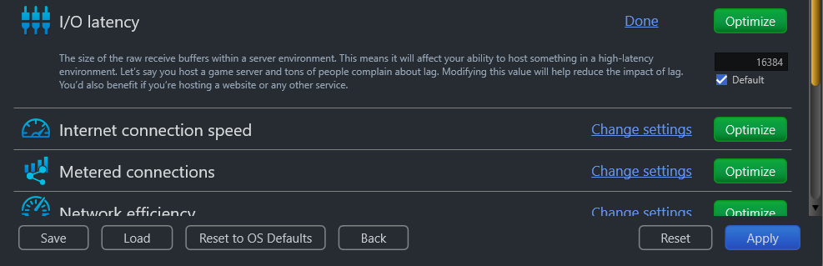

Figure –I/O latency easel

1. Change the **Raw Receive Buffer** parameter value as per your requirements and click the **Optimize** button. The green Optimize button is replaced by a blue **Pending** button.

**Tip:** Click the **Default** checkbox to revert to the default parameter settings. You can also click the **Done** link to close this easel.

**Tip:** In case you want to revert to the previous settings, click **Revert.**

**Tip:** To save your current settings, click **Save.** The Saves As dialog box is displayed which enables you to specify a folder location on your hard disk drive to save your current settings as a NetOptimizer presets (**\*.nop**) settings file. You can also save these settings on a USB thumb drive in case you want to load these settings on another system.

**Tip:** To load previously saved settings, click **Load.** The Open dialog box is displayed which enables you to navigate to the previously saved NetOptimizer presets (**\*.nop**) settings file.

**Tip:** To revert to the default settings of your operating system, click **Reset to OS Defaults.** NetOptimizerTM will reset all settings to default values of your Operating System.

**Tip:** To return to the NetOptimizerTM default screen, click **Back.**

1. Click **Apply** to apply your updated settings.

**Tip:** The system will prompt you to Restart your system. Click **Yes** to continue restarting your system or you can choose to click **No** to make changes to other settings.

**Tip:** After you have restarted your system, a green checkbox will be displayed against the optimized and saved setting.

## Optimizing Internet Connection Speed Settings

To optimize internet connection speed settings, the NetOptimizerTM application optimizes the **I/O Request Packet Stack Size** setting.

The **I/O Request Packet Stack Size** setting represents how many 36-byte receive buffers your computer can use simultaneously. It allows your computer to receive more data at the same time. If you have a high bandwidth Internet connection (more than 10 Mbps), you'll benefit from this significantly.

When the value is set high, your computer spends less time while delivering more data packets, effectively increasing the productivity in your network.

The steps described below enable you to optimize internet connection speed settings of your system –

1. From the Advanced Mode screen of the NetOptimizerTM application, click the **Change Settings** link as depicted in the figure below –



Figure – Advanced Mode screen

The Internet connection speed easel is opened as depicted in the figure below –

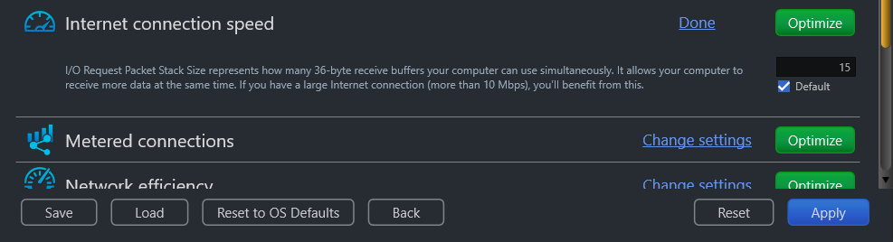

Figure – Internet connection speed easel

1. Change the **I/O Request Packet Stack Size** parameter as per your requirements and click the **Optimize** button. The green Optimize button is replaced by a blue **Pending** button.

**Tip:** Click the **Default** checkbox to revert to the default parameter settings. You can also click the **Done** link to close this easel.

**Tip:** In case you want to revert to the previous settings, click **Revert.**

**Tip:** To save your current settings, click **Save.** The Saves As dialog box is displayed which enables you to specify a folder location on your hard disk drive to save your current settings as a NetOptimizer presets (**\*.nop**) settings file. You can also save these settings on a USB thumb drive in case you want to load these settings on another system.

**Tip:** To load previously saved settings, click **Load.** The Open dialog box is displayed which enables you to navigate to the previously saved NetOptimizer presets (**\*.nop**) settings file.

**Tip:** To revert to the default settings of your operating system, click **Reset to OS Defaults.** NetOptimizerTM will reset all settings to default values of your Operating System.

**Tip:** To return to the NetOptimizerTM default screen, click **Back.**

1. Click **Apply** to apply your updated settings.

**Tip:** The system will prompt you to Restart your system. Click **Yes** to continue restarting your system or you can choose to click **No** to make changes to other settings.

**Tip:** After you have restarted your system, a green checkbox will be displayed against the optimized and saved setting.

## Optimizing Metered Connection Settings

To optimize metered connection settings, the NetOptimizerTM application optimizes the **Connection Type** setting – **Ethernet**, **Wifi**, **3G**, & **4G**

Setting the required **Connection Type** setting – **Ethernet**, **Wifi**, **3G**, & **4G** governs which internet connection types are to be optimized. Typically, cellular connections like 3G & 4G are set as metered connections which have an upper data limit usage set for them. Wifi & Ethernet are not set as metered connections by default. Some apps might work differently on a metered connection to help reduce your data usage.

When the **Connection Type** is set incorrectly as per your network setup, your computer spends more time waiting for a packet to deliver depending in case your connection is metered, effectively decreasing the productivity in your network.

The steps described below enable you to optimize metered connection settings of your system –

1. From the Advanced Mode screen of the NetOptimizerTM application, click the **Change Settings** link as depicted in the figure below –



Figure – Advanced Mode screen

The Metered connection easel is opened as depicted in the figure below –

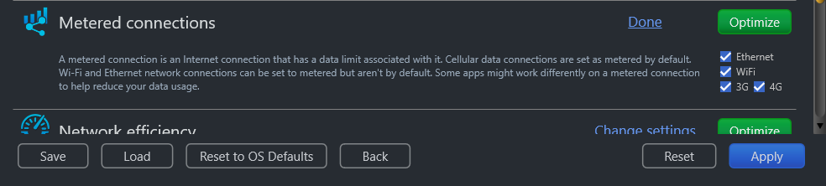

Figure – Metered connection easel

1. Select the appropriate **Connection Type** setting – **Ethernet**, **Wifi**, **3G**, and / or **4G** checkbox as per your requirements and click the **Optimize** button. The green Optimize button is replaced by a blue **Pending** button.

**Tip:** Click the **Default** checkbox to revert to the default parameter settings. You can also click the **Done** link to close this easel.

**Tip:** In case you want to revert to the previous settings, click **Revert.**

**Tip:** To save your current settings, click **Save.** The Saves As dialog box is displayed which enables you to specify a folder location on your hard disk drive to save your current settings as a NetOptimizer presets (**\*.nop**) settings file. You can also save these settings on a USB thumb drive in case you want to load these settings on another system.

**Tip:** To load previously saved settings, click **Load.** The Open dialog box is displayed which enables you to navigate to the previously saved NetOptimizer presets (**\*.nop**) settings file.

**Tip:** To revert to the default settings of your operating system, click **Reset to OS Defaults.** NetOptimizerTM will reset all settings to default values of your Operating System.

**Tip:** To return to the NetOptimizerTM default screen, click **Back.**

1. Click **Apply** to apply your updated settings.

**Tip:** The system will prompt you to Restart your system. Click **Yes** to continue restarting your system or you can choose to click **No** to make changes to other settings.

**Tip:** After you have restarted your system, a green checkbox will be displayed against the optimized and saved setting.

## Optimizing Network Efficiency Settings

To optimize network efficiency settings, the NetOptimizerTM application optimizes the **Nagle’s Algorithm Usage** setting.

The **Nagle’s Algorithm Usage** setting attempts to increase overall network efficiency by holding small bits of data until there is enough to create and transmit a full packet.

When the value is set as **Enabled**, your computer spends more time waiting for more data bits to arrive to group them as a full data packet, effectively decreasing the productivity in your network. This is why we set this to **Disabled** to increase network productivity.

The steps described below enable you to optimize network efficiency settings of your system –

1. From the Advanced Mode screen of the NetOptimizerTM application, click the **Change Settings** link as depicted in the figure below –



Figure – Advanced Mode screen

The Network efficiency easel is opened as depicted in the figure below –

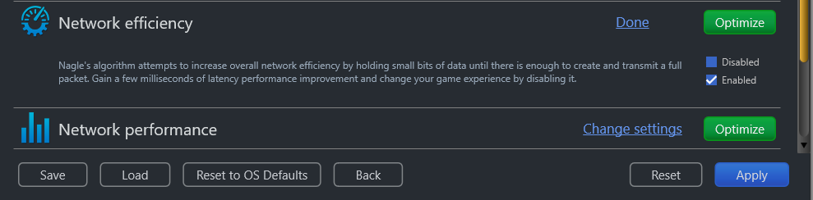

Figure – Network efficiency easel

1. Set the **Nagle’s Algorithm Usage** parameter to **Disabled** and click the **Optimize** button. The green Optimize button is replaced by a blue **Pending** button.

**Tip:** Click the **Default** checkbox to revert to the default parameter settings. You can also click the **Done** link to close this easel.

**Tip:** In case you want to revert to the previous settings, click **Revert.**

**Tip:** To save your current settings, click **Save.** The Saves As dialog box is displayed which enables you to specify a folder location on your hard disk drive to save your current settings as a NetOptimizer presets (**\*.nop**) settings file. You can also save these settings on a USB thumb drive in case you want to load these settings on another system.

**Tip:** To load previously saved settings, click **Load.** The Open dialog box is displayed which enables you to navigate to the previously saved NetOptimizer presets (**\*.nop**) settings file.

**Tip:** To revert to the default settings of your operating system, click **Reset to OS Defaults.** NetOptimizerTM will reset all settings to default values of your Operating System.

**Tip:** To return to the NetOptimizerTM default screen, click **Back.**

1. Click **Apply** to apply your updated settings.

**Tip:** The system will prompt you to Restart your system. Click **Yes** to continue restarting your system or you can choose to click **No** to make changes to other settings.

**Tip:** After you have restarted your system, a green checkbox will be displayed against the optimized and saved setting.

## Optimizing Network Performance Settings

To optimize network performance settings, the NetOptimizerTM application optimizes the **Windows Scale Factor** setting.

The **Windows Scale Factor** setting let’s your system adjust the Windows network scaling size between 65,535 bytes up to 1 GB. The scale factor can be set between 0 to 14. This is typically set high for high bandwidth networks.

When the value is set high, your computer spends more time waiting for the Windows scaling to complete, effectively decreasing the productivity in your network. This is why setting this to a lower factor value increases network productivity.

The steps described below enable you to optimize network performance settings of your system –

1. From the Advanced Mode screen of the NetOptimizerTM application, click the **Change Settings** link as depicted in the figure below –



Figure – Advanced Mode screen

The Network performance easel is opened as depicted in the figure below –

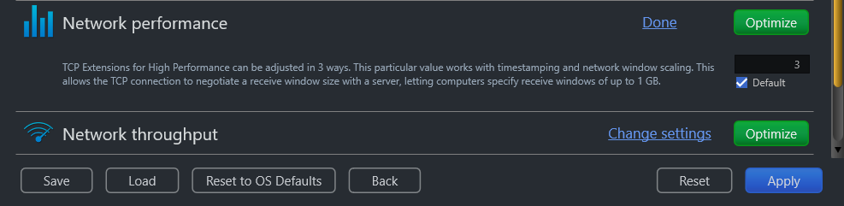

Figure – Network performance easel

1. Change the **Windows Scale Factor** parameter as per your requirements, preferably to **3**. and click the **Optimize** button. The green Optimize button is replaced by a blue **Pending** button.

**Tip:** Click the **Default** checkbox to revert to the default parameter settings. You can also click the **Done** link to close this easel.

**Tip:** In case you want to revert to the previous settings, click **Revert.**

**Tip:** To save your current settings, click **Save.** The Saves As dialog box is displayed which enables you to specify a folder location on your hard disk drive to save your current settings as a NetOptimizer presets (**\*.nop**) settings file. You can also save these settings on a USB thumb drive in case you want to load these settings on another system.

**Tip:** To load previously saved settings, click **Load.** The Open dialog box is displayed which enables you to navigate to the previously saved NetOptimizer presets (**\*.nop**) settings file.

**Tip:** To revert to the default settings of your operating system, click **Reset to OS Defaults.** NetOptimizerTM will reset all settings to default values of your Operating System.

**Tip:** To return to the NetOptimizerTM default screen, click **Back.**

1. Click **Apply** to apply your updated settings.

**Tip:** The system will prompt you to Restart your system. Click **Yes** to continue restarting your system or you can choose to click **No** to make changes to other settings.

**Tip:** After you have restarted your system, a green checkbox will be displayed against the optimized and saved setting.

## Optimizing Network Throughput Settings

To optimize network throughput settings, the NetOptimizerTM application optimizes the **TCP Max Window Size** setting.

The **TCP Max Window Size** setting can be adjusted if you have a high bandwidth Internet connection (10 Mbps and above) and often upload stuff. This value represents how much data can be sent from your computer without receiving an acknowledgement (ACK) packet. This is often set high for high bandwidth internet connections.

When the value is set high, your computer spends more time waiting to receive an acknowledgement, effectively decreasing the productivity in your network.

The steps described below enable you to optimize network throughput settings of your system –

1. From the Advanced Mode screen of the NetOptimizerTM application, click the **Change Settings** link as depicted in the figure below –

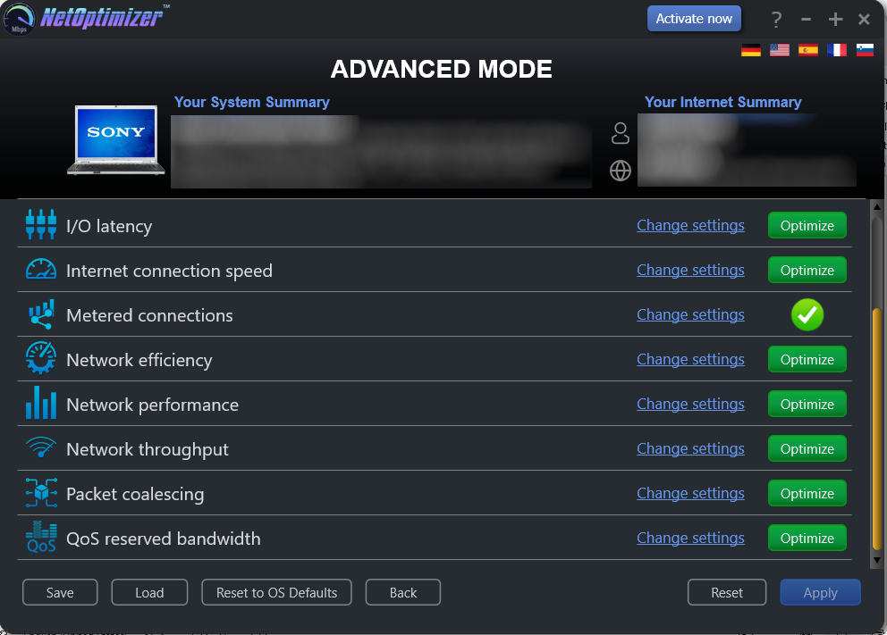

Figure – Advanced Mode screen

The Network throughput easel is opened as depicted in the figure below –

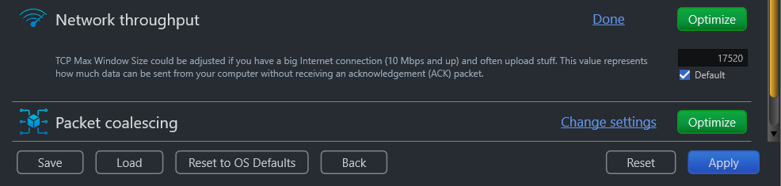

Figure – Network throughput easel

1. Change the **TCP Max Window Size** parameter as per your requirements and click the **Optimize** button. The green Optimize button is replaced by a blue **Pending** button.

**Tip:** Click the **Default** checkbox to revert to the default parameter settings. You can also click the **Done** link to close this easel.

**Tip:** In case you want to revert to the previous settings, click **Revert.**

**Tip:** To save your current settings, click **Save.** The Saves As dialog box is displayed which enables you to specify a folder location on your hard disk drive to save your current settings as a NetOptimizer presets (**\*.nop**) settings file. You can also save these settings on a USB thumb drive in case you want to load these settings on another system.

**Tip:** To load previously saved settings, click **Load.** The Open dialog box is displayed which enables you to navigate to the previously saved NetOptimizer presets (**\*.nop**) settings file.

**Tip:** To revert to the default settings of your operating system, click **Reset to OS Defaults.** NetOptimizerTM will reset all settings to default values of your Operating System.

**Tip:** To return to the NetOptimizerTM default screen, click **Back.**

1. Click **Apply** to apply your updated settings.

**Tip:** The system will prompt you to Restart your system. Click **Yes** to continue restarting your system or you can choose to click **No** to make changes to other settings.

**Tip:** After you have restarted your system, a green checkbox will be displayed against the optimized and saved setting.

## Optimizing Packet Coalescing Settings

To optimize packet coalescing settings, the NetOptimizerTM application optimizes it by setting it to **Enabled**.

**Packet Coalescing** groups multiple data packets to reduce the number of processor interrupts required.

When the value is set **Enabled**, your computer requires lesser processing power, effectively increasing the productivity in your network.

The steps described below enable you to optimize packet coalescing settings of your system –

1. From the Advanced Mode screen of the NetOptimizerTM application, click the **Change Settings** link as depicted in the figure below –



Figure – Advanced Mode screen

The Packet coalescing easel is opened as depicted in the figure below –

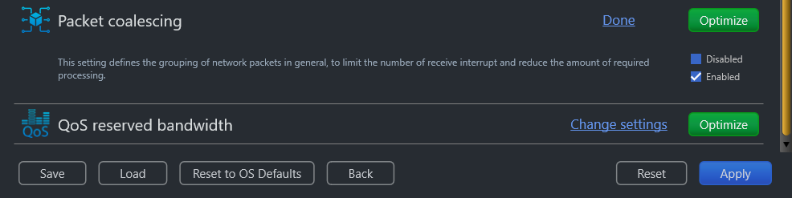

Figure – Packet coalescing easel

1. Select the **Enabled** checkbox and click the **Optimize** button. The green Optimize button is replaced by a blue **Pending** button.

**Tip:** Click the **Default** checkbox to revert to the default parameter settings. You can also click the **Done** link to close this easel.

**Tip:** In case you want to revert to the previous settings, click **Revert.**

**Tip:** To save your current settings, click **Save.** The Saves As dialog box is displayed which enables you to specify a folder location on your hard disk drive to save your current settings as a NetOptimizer presets (**\*.nop**) settings file. You can also save these settings on a USB thumb drive in case you want to load these settings on another system.

**Tip:** To load previously saved settings, click **Load.** The Open dialog box is displayed which enables you to navigate to the previously saved NetOptimizer presets (**\*.nop**) settings file.

**Tip:** To revert to the default settings of your operating system, click **Reset to OS Defaults.** NetOptimizerTM will reset all settings to default values of your Operating System.

**Tip:** To return to the NetOptimizerTM default screen, click **Back.**

1. Click **Apply** to apply your updated settings.

**Tip:** The system will prompt you to Restart your system. Click **Yes** to continue restarting your system or you can choose to click **No** to make changes to other settings.

**Tip:** After you have restarted your system, a green checkbox will be displayed against the optimized and saved setting.

## Optimizing QoS Reserved Bandwidth Settings

To optimize QoS reserved bandwidth settings, the NetOptimizerTM application optimizes the **Limit Reservable Bandwidth** setting.

The **Limit Reservable Bandwidth** setting governs the Windows QoS Packet Scheduler which reserves 20% of bandwidth by default for Quality of Service (QoS)-aware applications that request priority traffic.

This directly affects the running QoS applications that request priority traffic, like Windows Update, for example. i.e. such applications & processes are assigned higher priority.

When the value is set high, your computer prioritizes the specified percentage of your internet bandwidth to QoS applications and processes, effectively decreasing the productivity in your network.

To prevent QoS applications from getting priority to 20% of available bandwidth, this feature can be disabled by setting it to 0%, effectively increasing the productivity in your network.

The steps described below enable you to optimize QoS reserved bandwidth settings of your system –

1. From the Advanced Mode screen of the NetOptimizerTM application, click the **Change Settings** link as depicted in the figure below –



Figure – Advanced Mode screen

The QoS reserved bandwidth easel is opened as depicted in the figure below –

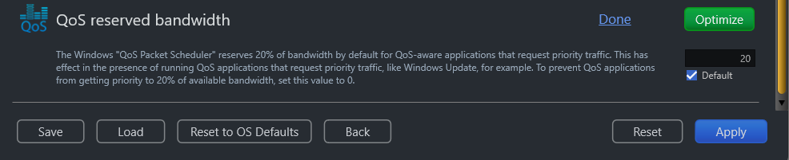

Figure – QoS reserved bandwidth easel

1. Set the **Limit Reservable Bandwidth** parameter to 0% to disable this setting and click the **Optimize** button. The green Optimize button is replaced by a blue **Pending** button.

**Tip:** Click the **Default** checkbox to revert to the default parameter settings. You can also click the **Done** link to close this easel.

**Tip:** In case you want to revert to the previous settings, click **Revert.**

**Tip:** To save your current settings, click **Save.** The Saves As dialog box is displayed which enables you to specify a folder location on your hard disk drive to save your current settings as a NetOptimizer presets (**\*.nop**) settings file. You can also save these settings on a USB thumb drive in case you want to load these settings on another system.

**Tip:** To load previously saved settings, click **Load.** The Open dialog box is displayed which enables you to navigate to the previously saved NetOptimizer presets (**\*.nop**) settings file.

**Tip:** To revert to the default settings of your operating system, click **Reset to OS Defaults.** NetOptimizerTM will reset all settings to default values of your Operating System.

**Tip:** To return to the NetOptimizerTM default screen, click **Back.**

1. Click **Apply** to apply your updated settings.

**Tip:** The system will prompt you to Restart your system. Click **Yes** to continue restarting your system or you can choose to click **No** to make changes to other settings.

**Tip:** After you have restarted your system, a green checkbox will be displayed against the optimized and saved setting.

The next chapter describes steps that enable you to view the **Wi-Fi Passwords** of the wifi connection that your system is connected to.

# Viewing the Wi-Fi Passwords

The steps described below enable you to view the wifi password of the connection that your system is connected to –

1. From the default screen of the NetOptimizerTM application, click the **Wi-Fi Passwords** button as depicted in the figure below.



Figure – Viewing the Wi-Fi Passwords

The Wi-Fi Passwords screen is displayed as depicted in the figure below –

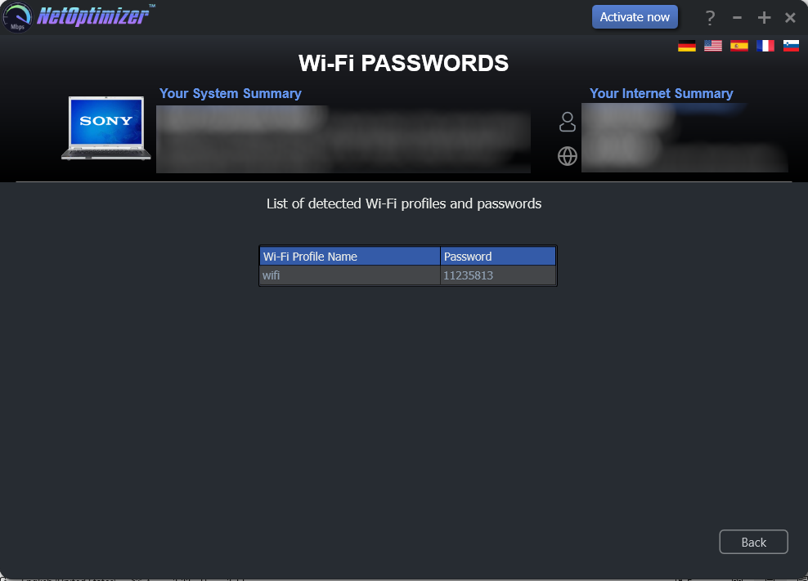

Figure – Automatic execution of the Auto Mode system analysis wizard

1. Click **Back** to return to the NetOptimizerTM default screen.

The next chapter describes steps that enable you to use the **Browser Cleanup** feature of the NetOptimizer TM application.

# Using the Browser Cleanup Feature

The steps described below enable you to use the browser cleanup feature of the NetOptimizerTM application –

1. From the default screen of the NetOptimizerTM application, click the **Browser Cleanup** button as depicted in the figure below.



Figure – Using the Browser Cleanup Feature

The Browser Cleanup screen is displayed as depicted in the figure below –

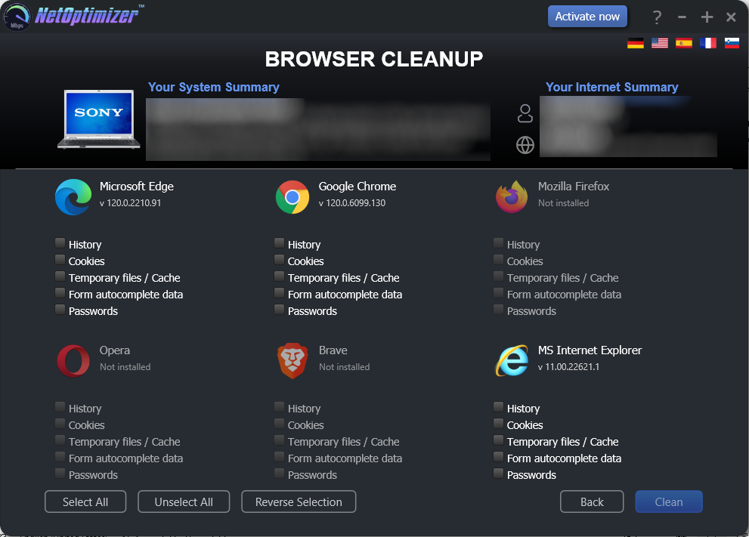

Figure – Browser cleanup screen

1. You can specify which cleaning tasks are to be performed by clicking the corresponding checkboxes for each browser one-by-one or you can click the **Select** **All** button to select all checkbox options. You can also click **Unselect** **All** to unselect any or all checkboxes that you may have previously selected or you can click **Remove** **Selection** to remove your selections.

**Tip:** You can only select corresponding options for the web-browsers that are installed on your system. The Clean button will only be enabled once you make at least one selection for the installed browser of your choice.

1. Click **Clean** to clean your web browsers as per your selections. The NetOptimizerTM application will query you to continue the cleanup procedure as per your selections as depicted in the figure below –

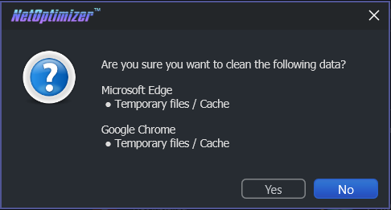

Figure – Querying for Cleanup task confirmation

1. Click **Yes** to continue cleaning up the specified web-browser(s) or click **No** abort continuing with this cleanup task.

**Tip:** You can change your selections by repeating steps 2 and 3 described in this section or you can click **Back** to return the NetOptimizerTM default screen.

1. In case your web-browsers are open, the application will prompt you to close them as depicted in the figure below –

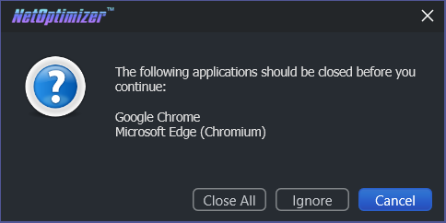

Figure – Querying for closing open web-browsers

1. Click **Close All** to close your web-browsers.

**Tip:** Click **Ignore** to perform the cleanup task without closing your web-browsers.

Once the cleanup task has been completed, a popup confirming the same will be displayed as depicted in the figure below –

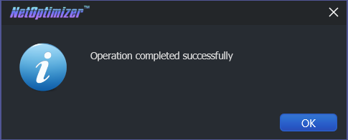

Figure – Successful Operation completion status message

1. Click **OK** to continue. You will be viewing the Browser Cleanup screen as depicted in the figure below-



Figure – Browser cleanup screen

1. Click **Back** to return to the NetOptimizerTM default screen.

The next chapter describes steps that enable you to use the **Speed Test** feature of the NetOptimizer TM application.

# Using the Speed Test Feature

The steps described below enable you to use the speed test feature of the NetOptimizerTM application –

1. From the default screen of the NetOptimizerTM application, click the **Speed Test** button as depicted in the figure below.



Figure – Using the Speed Test Feature

The Speed Test screen is displayed as depicted in the figure below –

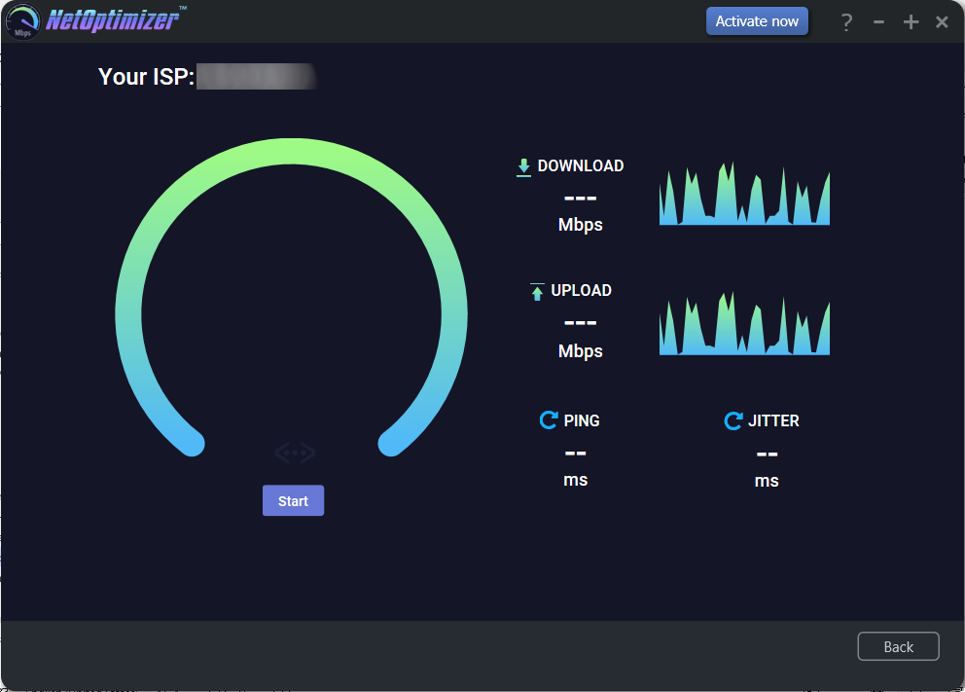

Figure – Speed Test screen

1. Click **Start** to start testing your download and upload bandwidth as per your selections as depicted in the figure below –

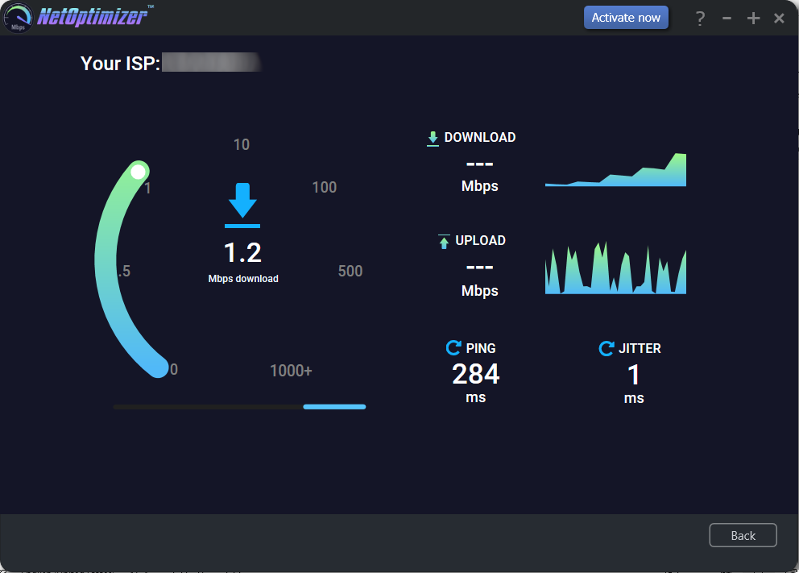

Figure – Collecting your Internet Connection Speed Statistics

After the testing process has completed, the statistical data collected about your internet connection speed is displayed as depicted in the figure below –

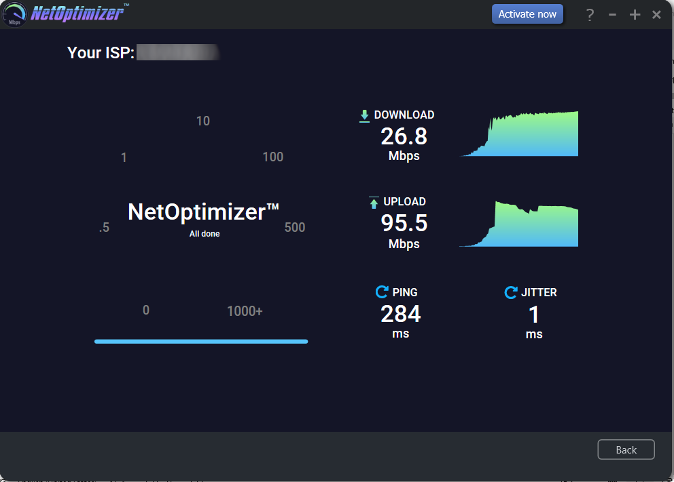

Figure – Your Internet Connection Speed Statistics

1. Click **Back** to return to the NetOptimizerTM default screen.

The next chapter describes steps that enable you to use the **Diagnostic Troubleshooting** feature of the NetOptimizer TM application.

# Using the Diagnostic Troubleshooting Feature

The steps described below enable you to use the diagnostic troubleshooting feature of your system –

1. From the default screen of the NetOptimizerTM application, click the **Click here** link as depicted in the figure below.



Figure – Using the Diagnostic Troubleshooting Feature

The Diagnostic Troubleshooting screen is displayed as depicted in the figure below –

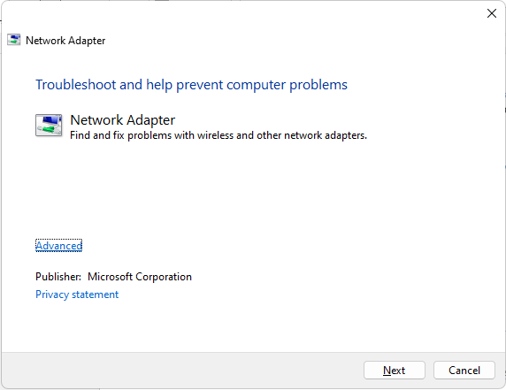

Figure – Diagnostic troubleshooting wizard

1. Click **Next** to execute the Diagnostic Troubleshooting wizard or click **Cancel** to return to the NetOptimizerTM default screen.

**Tip:** For more information, refer to the user manual of your operating system.

The next chapter describes steps that enable you to Activate your NetOptimizerTM installation.

# Activating your NetOptimizerTM Installation

In case you have not activated your NetOptimizerTM application while using the Auto Mode network optimization wizard, you can utilize the steps described below which enable you to activate your NetOptimizerTM application installation –

1. From the default screen of the NetOptimizerTM application, click the **Activate Now** button as depicted in the figure below.



Figure – Activating your NetOptimizerTM Installation

The Key Application popup is displayed as depicted in the figure below –



Figure – Key application popup

1. Click the **Buy Now** button to avail the money saving offer depicted here.

**Tip:** You will be navigated to the NetOptimizerTM shopping cart web page in your default web browser. You can specify the required details, and click **Buy Now** on this web page to make your purchase. You will receive an email containing your license key details at the email address specified by you on this web page.

1. Once you have received your license key, specify your email address and license key and click the **Submit** button. After successful validation of the specified key, your NetOptimizerTM installation will be activated and a popup will be displayed confirming the same as depicted in the figure below –



Figure – Successful application of your license key

1. Click **Continue** to continue using the NetOptimizerTM application. The Activate Now button will be removed from the NetOptimizerTM default screen.

**Tip:** To view the license details, you can click the **Question Mark (?)** button on the NetOptimizerTM default screen.

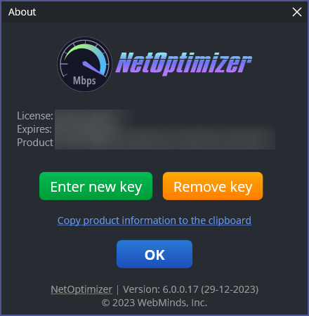

Figure – Viewing your license key details

1. Click **Enter New Key** in case you intend to specify a new license key or click **OK** to continue using the NetOptimizerTM application.

**Tip:** Click the **Copy product information to the clipboard** link to copy the license details. You can paste this key in a document of your choice for safekeeping.

The next chapter describes steps that enable you to Remove your NetOptimizerTM license key.

# Removing your NetOptimizerTM License Key

Once you have activated your NetOptimizerTM application with a valid license key which has not expired yet, you can utilize the steps described below which enable you to remove this key so that you can reuse it on another system or the same system at a later date provided it has not expired –

1. From the default screen of the NetOptimizerTM application, click the **Question Mark (?)** button as depicted in the figure below.

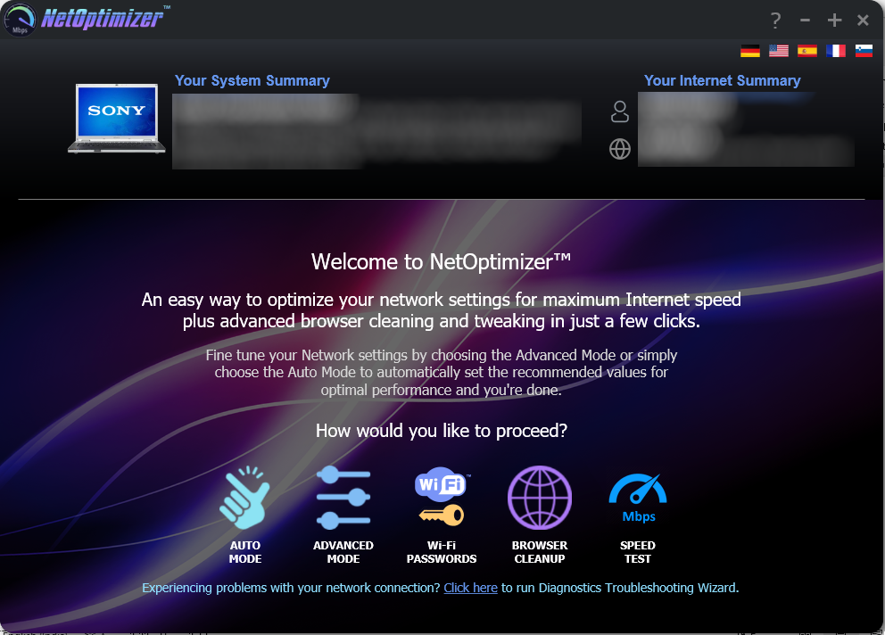

Figure – Removing your NetOptimizerTM License Key

The About popup is displayed as depicted in the figure below –



Figure – Viewing your license key details

1. Click **Remove Key** to remove your license key.

**Tip:** Click the **Copy product information to the clipboard** link to copy the license details. You can paste this key in a document of your choice for safekeeping.

1. After you have clicked on **Remove Key**, the application will query you for your confirmation as depicted in the figure below –

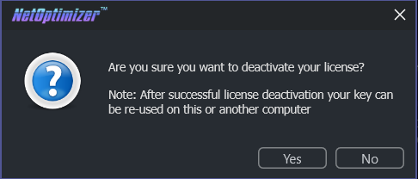

Figure – License key deactivation confirmation message

1. Click **Yes** to continue to deactivating your license key or click **No** to continue using your already specified license key. If you clicked **Yes**, a deactivation successful status message will be displayed as depicted in the figure below –

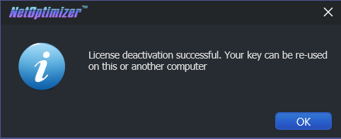

Figure – License key deactivation successfully status message

1. Click **Ok** to continue using the NetOptimizerTM application.

The next section of this user manual **Frequently Asked Questions (FAQs)** as an appendix.

1. Frequently Asked Questions (FAQs)

Here is a list of frequently asked questions with reference to the NetOptimizerTM application and its usage –

How can NetOptimizer™ help me?

NetOptimizerTM is an advanced system utility that checks your computer for non-optimal Internet connection settings and enables you to apply the best possible settings for your connection type automatically. With its help, you’ll be able to fine-tune your PC to get the actual connection speed as advertised by your Internet service provider.

Do I need to install NetOptimizer™ on my computer?

Yes. After you have downloaded the single-click executable .exe file from the below link, you can install the application by following the easy-to-use installation wizard.

**Reference:** To download the NetOptimizerTM application installer, click the following link – https://www.netoptimizer.com/files/NetOptimizer.exe. The system may prompt you to restart itself to finish installing the NetOptimizerTM application. Please save your work and restart your system at this point.

What are the minimum system requirements for NetOptimizer™?

The minimum system requirements for NetOptimizerTM are:

* Windows XP SP3 or newer
* 1 GHz CPU (both 32-bit and 64-bit platforms are supported)
* 128 MB RAM
* 32 MB disk space
* Screen size of 1024×768 or larger

Which versions of Windows is NetOptimizer™ compatible with?

NetOptimizerTM is compatible with the following versions of Windows –

* Windows XP
* Windows Vista
* Windows 7
* Windows 8
* Windows 10
* Windows 11

Which settings can I optimize with NetOptimizer™?

NetOptimizerTM fine-tunes hidden Windows network settings such as TCP settings, TTL, I/O parameters, and network efficiency.

**Reference:** For more information, see **Using the Advanced Mode** chapter.

Does NetOptimizer™ support metered connections?

Yes, NetOptimizerTM has a special setting for metered connections and can optimize your PC’s network settings for best results on 3G, 4G, and 5G.

How does NetOptimizer™ know the best settings for my computer?

NetOptimizerTM quickly checks your Internet connection type and your operating system’s parameters to determine if anything needs to be adjusted. If your settings are already optimal, you’ll see green checkmarks next to those settings.

Is NetOptimizer™ safe to use?

Yes, NetOptimizerTM is absolutely safe to use because you can always undo any changes made by the application by clicking on the **Reset to OS Defaults** button on the **Advanced Mode** screen.

**Reference:** For more information, see **Using the Advanced Mode** chapter.

What are the trial version limitations?

The trial version of NetOptimizer lets you find the optimal Internet connection settings but it doesn’t let you apply & save them. For that, you’ll need to purchase a license.

**Reference:** For more information, click the **Buy Now** button on the [**NetOptimizerTM official website**](https://www.netoptimizer.com/) page header or use this link – <https://www.netoptimizer.com/cart/>

Why is there an expiration date on my NetOptimizerTM license?

When you purchase a license for NetOptimizerTM, the license unlocks the program forever, so that you can use NetOptimizer for as long as you want. As for the expiry date, it’s set to show you the period during which you will be able to download free updates. Once the license expires, you can continue using your version of the program, but you will need to extend your license to continue getting updates and have access to email support.

**Tip:** Remember that each computer is assigned a unique license ID. Once activated, this license will not work on any other computer while it is being used on a given system provided it is still valid.

Can I reuse my license on another system?

Yes. You can reuse you existing valid license on another system but you will first require removing it from the system it is being used currently.

**Tip:** For more information, see **Removing your NetOptimizerTM License Key** & **Activating your NetOptimizerTM Installation** chapters.

**Warning:** Ensure to remove your existing valid license before resetting or reformatting your current Windows installation.

I’m trying to register NetOptimizer but it’s not working. What to do?

There may be a few issues that may prevent the activation of the product, including:

Your UAC (User Account Control) settings in Windows Vista, Windows 7, Windows 8, Windows 10 and Windows 11. When that’s the case, close NetOptimizerTM, then right-click on its shortcut on your desktop and select **Run as administrator**. Then proceed to register the program.

Your firewall or anti-virus programs may be preventing changes to your computer. Even the changes such as registering your product. Try disabling your security software temporarily and proceed with product registration.

**Tip:** In case you are still facing issues, please fill the **Get in Touch** form provided on the [**Support**](https://www.netoptimizer.com/support/) page and submit your details along with the issue you are facing. To do so, click the following link – [**https://www.netoptimizer.com/support/**](https://www.netoptimizer.com/support/)**.** We are more than happy to assist you in using the NetOptimizerTM application.

The next section of this user manual includes an **Index** of frequently referred terms or phrases with reference to the NetOptimizerTM application and its usage.

Index

A

Abbreviations / Acronyms used in this User Manual v

About this User Manual iii

Activating your NetOptimizerTM Installation 47

C

Can I reuse my license on another system? 53

D

Do I need to install NetOptimizer™ on my computer? 51

Does NetOptimizer™ support metered connections? 52

F

Frequently Asked Questions (FAQs) 51

G

Getting Started 11

H

How can NetOptimizer™ help me? 51

How does NetOptimizer™ know the best settings for my computer? 52

I

I’m trying to register NetOptimizer but it’s not working. What to do? 54

In Scope of this User Manual iii

Intended Audience of this User Manual iii

Introduction 10

Is NetOptimizer™ safe to use? 52

O

Optimizing Data Caching Settings 17

Optimizing DNS Server Settings 19

Optimizing Host Resolution Priority Settings 22

Optimizing I/O Latency Settings 24

Optimizing Internet Connection Speed Settings 26

Optimizing Metered Connection Settings 28

Optimizing Network Efficiency Settings 30

Optimizing Network Performance Settings 32

Optimizing Network Throughput Settings 34

Optimizing Packet Coalescing Settings 36

Optimizing QoS Reserved Bandwidth Settings 38

Organization of this User Manual iii

Out of Scope of this User Manual iii

P

Purpose of this User Manual iii

R

Removing your NetOptimizerTM License Key 49

T

Terms Used in this User Manual v

Typographical Conventions / Customaries used in this User Manual iv

U

Using the Advanced Mode 16

Using the Auto Mode 13

Using the Browser Cleanup Feature 41

Using the Diagnostic Troubleshooting Feature 46

Using the Speed Test Feature 44

V

Viewing the Wi-Fi Passwords 40

W

What are the minimum system requirements for NetOptimizer™? 51

What are the trial version limitations? 53

Which settings can I optimize with NetOptimizer™? 52

Which versions of Windows is NetOptimizer™ compatible with? 52

Why is there an expiration date on my NetOptimizerTM license? 53